Getting Back to the Basics Unit
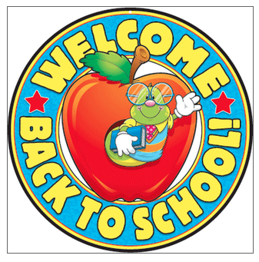

Name: ________________________________________ Period:_____

Pages Completed | Total Score
7 Pages Completed | 10
6 Pages Completed | 8
5 Pages Completed | 7
4 Pages Completed | 5
3 Pages Completed | 4
2 Pages Completed | 2
1 Page Completed | 1
No Pages Completed/Not Turned In | 0

LATE – 10% Deducted from Score = New Total Score: __________________

What is Science? Notes and Practice Questions

Words to Remember:
Word | Meaning
Science
Observation
Questioning
Inference
Hypothesis
Control
Independent Variable
Dependent Variable
Quantitative
Qualitative
Conclusion

Activity #1 – The Mystery Cubes In this activity, you will use scientific methodology to determine the 6th side of the cubes.DO NOT TOUCH THE CUBE!
A. NUMBER CUBE
- Questions about the cube:

- Observations?

- What is on the bottom of the cube?

B. NAME CUBE
- Questions about the cube:

- Observations?

- What do you conclude is at the bottom of the cube?

Activity #2 – Observation and Questions
A. OBSERVATIONS Look at the following list of objects. For each object, list a fact that you might observe. Next, list the sense you would use to make this observation. Then come up with a testable question about that fact

Object observed | Observation | Sense or senses | Question
- Perfume | It has a pleasant aroma | smell | Why do I consider this a pleasant aroma while someone might hate it?
- A bird singing
- A hot stove

B. QUESTIONS Turn each question or topic into a testable question.
- Is rock music better than hip-hop music? (not testable)
Ex. How do music sales vary by age and gender of the buyer, and by type of music?

- How is bug blood different from human blood?
- Is vegetarianism better than eating meat?

Activity #3 – Observation vs. Inference
A.. Write 3 observations and then write an inference about each observation in the cartoon.
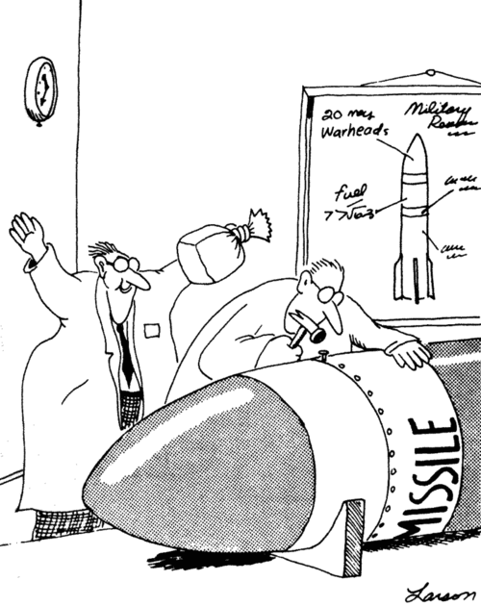
2 observations about the picture

2 inferences based on the observation

B. Suppose your friends went to the beach at noon on a warm day. They saw some black and white birds. Which of the following statements are observations and which are inferences?

1. It is summertime. _____
2. It is daytime. _____
3. They saw birds. _____
4. They saw seagulls. _____
5. They went swimming. _____

Activity #4 – Springville Science Fair
Read each of the experiment conducted by the residents of Springville. Answer the questions.
A. Smithers thinks that a special juice will increase the productivity of workers. He creates two groups of 50 workers each and assigns each group the same task (in this case, they're supposed to staple a set of papers). Group A is given the special juice to drink while they work. Group B is not given the special juice. After an hour, Smithers counts how many stacks of papers each group has made. Group A made 1,587 stacks, Group B made 2,113 stacks.
1. Hypothesis (ITB format):

2. Independent Variable
3. Dependent Variable
4. Control Group
5. What should Smithers' conclusion be?

Activity #5 – Analyzing Data
A. QUANTITATIVE VS. QUALITATIVE Write the following statement under the correct type of data

- The cup is half empty
- The temperature outside is 25º C.
- It is warm outside.
- The tree is 10 meters tall.
- The building has 25 stories.

QUALITATITVE | QUANTITATIVE

B. TABLES Use information provided to construct a data table Make sure your data table includes a title, column headings, units, and averages if appropriate. Use a ruler and a pencil or you can generate it in a computer.
1. You are a biologist studying the health of bald eagles in three states: Alaska, Idaho, and Montana. You know that the greater the mass of an adult bald eagle, the healthier it is. Therefore, you capture and find the mass of 4 bald eagles in each of the above states. You come up with the following data: In Alaska the 4 captured birds had a mass of 6.5 kg, 6.9 kg, 6.1 kg, and 5.7 kg; in Idaho their mass was 5.8 kg, 6.2. kg, 5.2 kg, and 4.9 kg; and in Montana it was 4.1 kg, 8.1 kg, 3.9 kg, and 5.1 kg. Draw a table to organize this data.

C. GRAPHS Use the data table to construct the graph below. Include a key if appropriate.
1. Bar graphs (2 bars)
Amount of Tadpoles Found In Water With Different pH
pH of water | Number of Species A | Number of Species B
8.0 | 45 | 57
7.5 | 69 | 59
7.0 | 78 | 63
6.5 | 88 | 95
6.0 | 43 | 89
5.5 | 23 | 60

Activity #6 – Conclusions
Go back to Activity #4 – Springville Science Fair. Write a conclusion to Smithers’ experiment. Use guidelines discussed in class. The conclusion has to have a minimum of 5 COMPLETE sentences. Remember to use correct grammar, spelling, punctuation, and voice.

Apply What You Learned
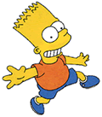
Bart believes that mice exposed to radio waves will become extra strong (maybe he's been reading too much Radioactive Man). He decides to perform this experiment by placing 10 mice near a radio for 5 hours. He compared these 10 mice to another 10 mice that had not been exposed. His test consisted of a heavy block of wood that blocked the mouse food. He found that 8 out of 10 of the radio waved mice looked strong and were able to push the block away. 7 out of 10 of the other mice looked strong and also pushed the block out of the way.
1. Hypothesis (ITB format):

2. Independent Variable
3. Dependent Variable
4. Control Group
5. Two pieces of Quantified Data: ________________________________________________________
6. Two pieces of Qualified Data: __________________________________________________________
Make a double bar graph that compares Bart’s results. (Remember TAILS—title, axis, intervals, labels, and scale!)

Write a 5-sentence conclusion for Bart’s experiment (Restate the purpose, summarize methods, major findings, was the hypothesis supported by data, how could the experiment be improved?):

